How to use parameter field for 'dat' & 'last' phase through ACE UI for "Add or Modify Seed Data" object types?

Few file types which require a deployment path as an input from ACE UI.

Below are the details of object type including their parameter name, parameter prompt and their default value.

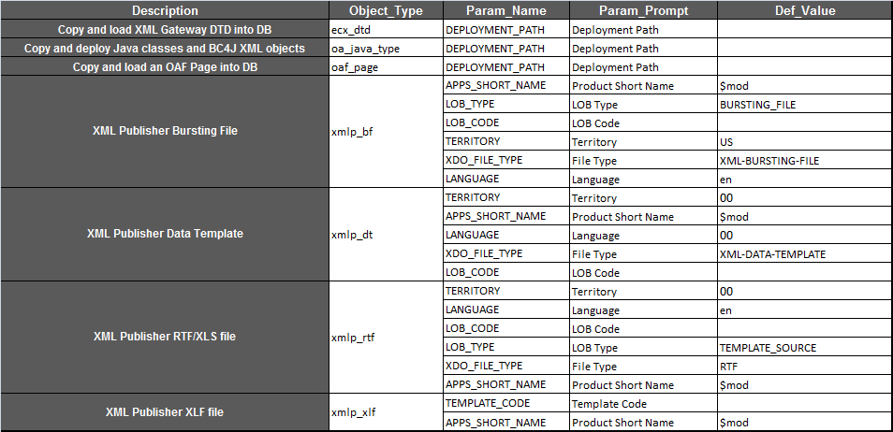

What are different phases ACE patches will support and what are the sequencing of phases?

ACE patches will work as similar to functional patches.

ACE patches will execute phase wise and each phase will execute in below mentioned order:

**NOTE: As per your 'Object Type' Selection during file upload via ACE it will create the patch driver sequence**

**Code uses the lines**

CEMLI_FILE_TYPE=<Object_Type> to identify specific file type for sql objects.

Packages are defaulted to c_pks can c_pkb automatically

